**Invention Disclosure Form**

**Description of Invention**

Q.1 – **Have you ever disclosed your invention to your friends/family or published it in journals? Any presentation/pitch you would have made regarding your invention?**

Ans. – Yes.

Q.2 – **Provide a short brief on the problem your invention is trying to solve.**

Ans. – Our project, "An IoT-Enabled Classroom Automation and Monitoring System," aims to create an energy-efficient and smart classroom that integrates technologies like smart lighting, emergency notification, and HVAC systems into a single, easy-to-manage system. This system will allow for monitoring of energy usage, device status, and classroom activity.

Q.3 – **Do you know any prior inventions that are currently targeting the same problem you are trying to solve?**

Ans. – No.

Q.4 – **Title of the Invention (Provide a title fitting the technical description of the invention and not a brand name)**

Ans. – Our Project Title is "An IoT-Enabled Classroom Automation and Monitoring System".

Q.5 – **Materials/Apparatus/Dimensions/Formulae/Components used for the preparation of invention along with their working in the invention (Depending on your invention)**

Ans. – NodeMCU ESP8266, Arduino Uno R3, Bread Board, Jumper Wires, DHT11 Temp & Humidity Sensor, PIR Sensor, 4-Channel Relay Module, LED Bulbs, DC Fan, Flame Sensor, Camera Module, RFID Module, TFT Screen, Microphone Sensor.

Q.6 –**What exactly is unique from the other solutions present in the world? How does it benefit the invention and its’ efficiency?**

Ans. – Our project stands out by offering a comprehensive Classroom Automation and Monitoring System using IoT, which includes solutions from other projects as well as addressing previously unaddressed problems. The system also provides a mobile application for administrators to have complete control.

Q.7 – **Provide basic working principle used for conduction of process to create invention. What fundamental principles are being used here?**

Ans. – We have proposed a system in which the existing appliances and devices present in a classroom can be controlled and monitored in real time, using a modern mobile application. We will send and receive data between the appliances and the Mobile App via Real- Time Database in the backend. The app will include several features like Emergency Notification on Intrusion Detection & Fire Detection. Also, we can monitor Classroom activities via the App.

Q.8 – **Any specific clause/feature/point you wish to include within the Claim Sets of the Patent Application?**

Ans. – Prototype Model and the Mobile Application designed and developed by us.

Q.9 – **Provide drawings in AUTOCAD or sketch along with a flowchart/step-by-step of the working model of an invention**.

Ans. –

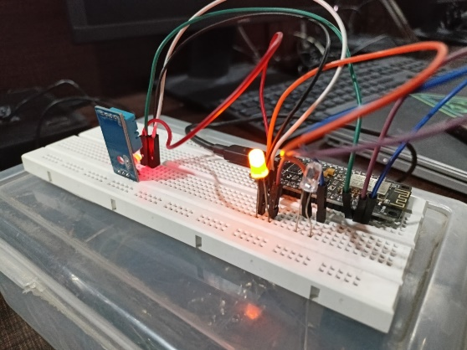

Q.10 – **Any other details you feel are necessary to be included in the Patent Application such as a “Specific Drawings, Code, Description, Tool used”.**

Ans. – Software to Develop Mobile Application - Android Studio, Visual Studio Code IDE. Arduino IDE,